Computer Language Coding Concepts

Simplified System Event Notation
System events can also be displayed using a simpler notation that uses line types to denote the aspect, and leaves out the aspect out of the displayed event name.

In the matrix below, reference-bound aspects are displayed with a parent around the event source and object-bound aspects are displayed without a parent around the event source.

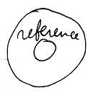

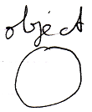

(It is not sure whether this will adequately disambiguate in practice. Hopefully using the diagram concept of automatic containment it will turn out not to be ambiguous, but that is not sure yet.)

Here follow the simplified notations for all the system events.

Reference Aspect

Getting Reference | Reference Gotten
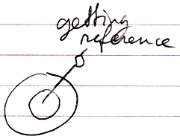 | 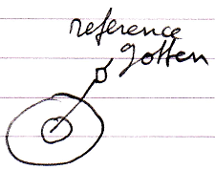

Object Aspect

Object Changed | Object Changing | Object Gotten | Getting Object
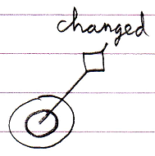 | 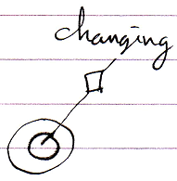 | 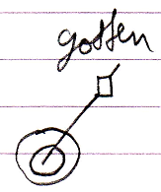 | 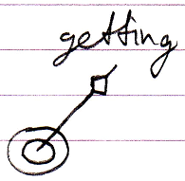
Reference Used As Object | Using Reference As Object
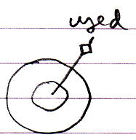 | 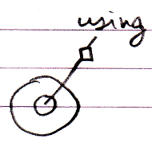

Class Aspect

Class Changed | Class Changing
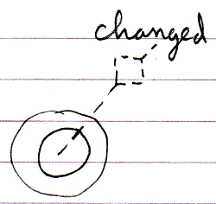 | 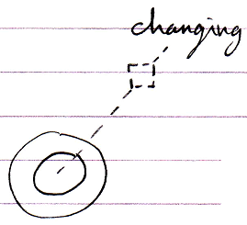
Used As Class | Using As Class | Reference Used As Class | Using Reference As Class
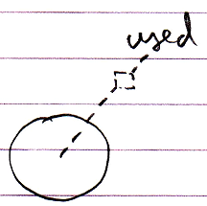 | 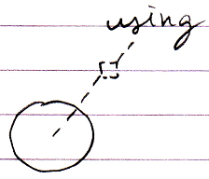 | 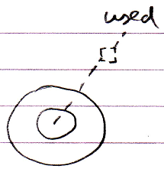 | 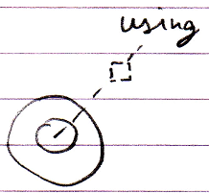
Reference-Class Gotten | Getting  Reference-Class | Object-Class  Gotten | Getting  Object-Class
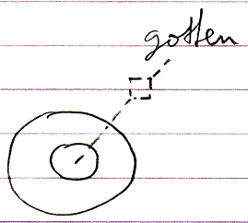 | 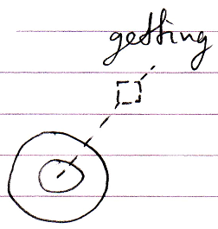 | 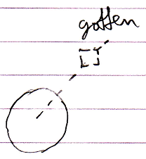 | 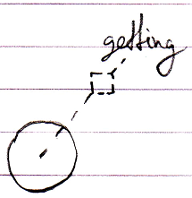

Interface Aspect

Interface Changed | Interface Changing
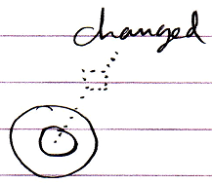 | 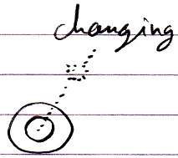
Used As Interface | Using As Interface | Reference Used As Interface | Using Reference As Interface
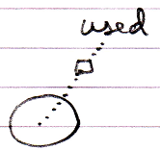 | 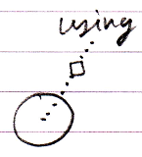 | 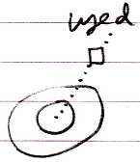 | 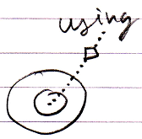
Reference-Interface Gotten | Getting Reference-Interface | Object-Interface Gotten | Getting Object-Interface
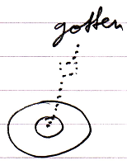 | 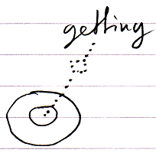 | 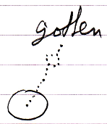 | 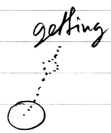

Interface Merged Aspect

Interface Merged Changed | Interface Merged Changing | Getting Interface Merged | Interface Merged Gotten
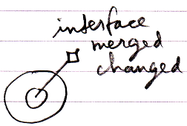 | 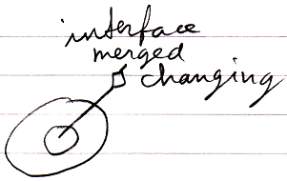 | 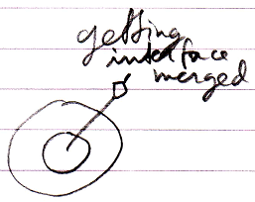 | 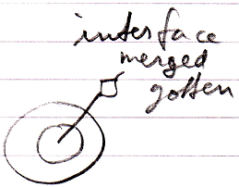

Value Aspect

Value Changed | Value Changing | Getting Value | Value Gotten
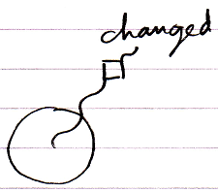 | 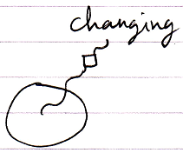 | 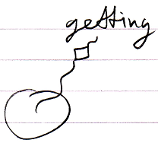 | 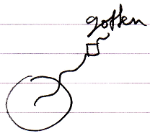

Clone Aspect

Clone Written | Writing Clone | Cloned | Cloning
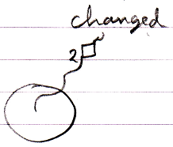 | 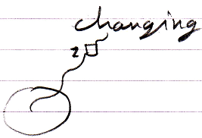 | 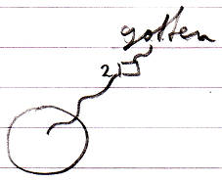 | 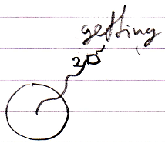

Data Aspect

Data Changed | Data Changing | Data Gotten | Getting Data
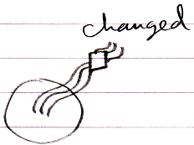 | 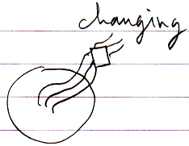 | 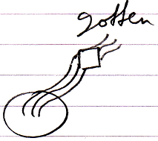 | 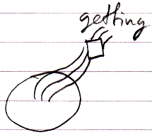

Name Aspect

Name Changed | Name Changing | Getting Name | Name Gotten
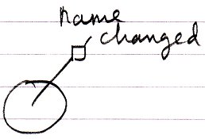 | 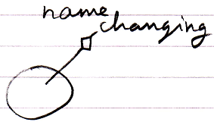 | 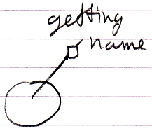 | 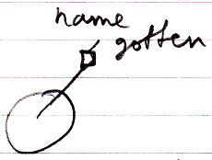

List Aspect

Added | Adding | Removing | Removed
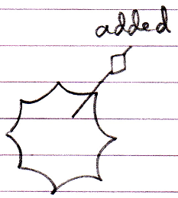 | 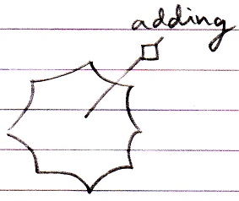 | 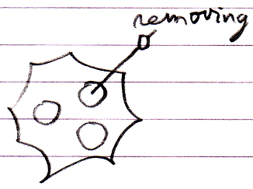 | 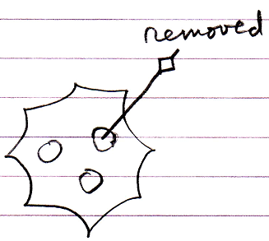
Storage Count Changed | Storage Count Changing
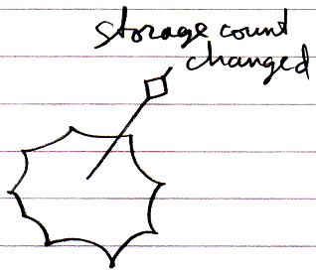 | 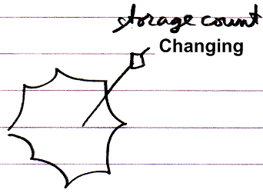

Execution Aspect

Executed | Executing
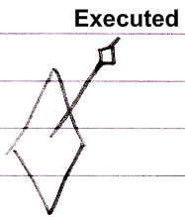 | 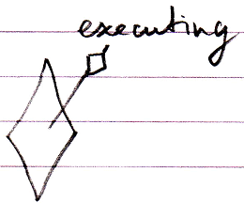

Existence Aspect

Created | Creating | Annulled | Annulling
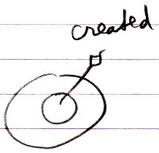 | 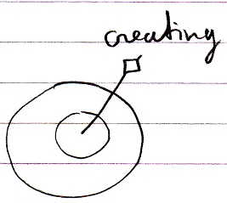 | 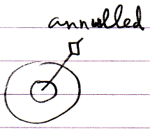 | 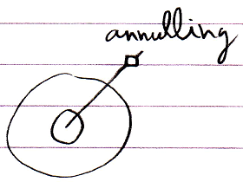

Some aspects have no associated line type, so they are not shown with a simplified notation, but with the normal notation. The above are the connectors, but the actual event commands look almost the same, but then without the loose end at the top.

Author & Copyright: Jan-Joost van Zon Date: May 10, 2010 – May 14, 2010 Location: Oosterhout, The Netherlands Status: Finished

